!!! figures may not be matching!!

Afera 5013 (GTF 6001) Test Method

Shear Adhesion Failure Temperature (SAFT) of Adhesive Tapes

1. Scope

1.1 This procedure will help determine the ability of an adhesive tape to remain adhered under a constant load applied parallel to the surface of the tape and substrate during a constantly increasing temperature. Shear adhesion (shear resistance) is the ability of a tape to resist static forces applied in the same plane as the backing.

2. Reference Documents

2.1 ASTM Standards:

D 3654/D 3654M Standard Test Method for Shear Adhesion of Pressure-Sensitive Tapes

D 3715 Standard Practice of Quality Assurance of Pressure-Sensitive Tapes

D 4498 Standard Test Method for Heat-Fail Temperature in Shear of Hot Melt Adhesives

D 5750 Standard Guidel for Widths and Lengths of Pressure-Sensitive Tapes

2.2 PSTC Standards:

2.2.1 PSTC-17 Shear Adhesion Failure Temperature of PSA Tapes

2.2.2 PSTC-107 Shear Adhesion of Adhesive Tapes

2.3 CEN Standards:

2.3.1 EN 1943 Adhesive Tapes – Measurement of Static Shear Adhesion

2.3.2 EN 10088/2, 2R – Specification for Stainless Steel Plate

2.4 ISO Standard:

2.4.1 ISO 29863 Adhesive Tapes - Measurement of Static Shear Adhesion

2.5 Afera Standard:

2.5.1 Afera 5012 Adhesive Tapes - Measurement of Static Shear Adhesion

Afera: The European Adhesive Tape Association

GTF: Global Tape Forum

ASTM: American Society for Testing and Materials (USA)

EN: European Norm (Europe)

ISO: International Organisation for Standardisation

PSTC: Pressure Sensitive Tape Council (USA)

3. Summary of Test Method

3.1 A strip of tape is applied to a standard steel panel under controlled roll down. The panel is mounted vertically in a programmable heating oven, a standard mass is attached to the free end of the tape, the oven temperature is increased at a constant, controlled rate, and the time to failure is determined.

4. Significance and Use

4.1 The shear adhesion failure temperature is the temperature at which the bond area fails cohesively in shear when a sample is subjected to a standard load.

5. Apparatus

5.1 Specimen cutter

The specimen cutter shall hold two single edge razor blades in parallel planes, a precise distance apart, to form a cutter of exact specimen width. A cutter 24 mm cutting width shall be available or appropriate alternates which will not cause edge damage.

Note 1: This width corresponds to the primary metric (SI) units described in ASTM D 5750. These so-called “modular metric” units are used throughout the world except for Europe. If it is desirable to test slightly different widths (e.g. 25 mm) of specimens per 9.4, this should be noted per 12.2.

Note 2: There may be several suppliers of this item.

5.2 Dispensing system, for solvents, such as a wash bottle

5.3 Panel

5.3.1 A panel at least 50 mm long and 50 mm wide and not less than 1.1 mm thickness stainless steel 302 or 304 in accordance with Specification EN 10088/2, 2R having a bright annealed finish. The surface roughness height shall be 50 ± 25 nm arithmetical average deviation from the mean line. At least one panel end shall form a 90° angle with the surface. Panels showing stains, discolouration or many scratches are not acceptable. Panels should be cleaned prior to use as 10.1.2, except with ten washes of final solvent. Between uses, the panel test surface shall be protected from scratches and contamination, and the panels stored at conditions described in 8.1.

5.4 Roller mechanically or hand operated

5.4.1 A steel roller 85 ± 2.5 mm in diameter and 45 ± 1.5 mm in width , covered with rubber approximately 6 mm thickness, having a Shore scale A durometer hardness of 80 ± 5. The surface shall be a true cylinder void of any convex or concave deviations. The mass of the roller shall be 2 ± 0.1 kg.

5.4.2 No part of the apparatus shall increase the pressure of the roller during use. The roller shall move either mechanically or by hand at the rate of 600 ± 20 mm/min.

5.5 Test stands and ancillary apparatus

5.5.1 The test stand that shall hold the test panel (see Figure 1), with the tape applied, at an angle of 2° ± 1°, with the vertical, so that when the mass is acting on the test specimen, no peel forces will be exerted on the tape (see Fig. 2).

5.5.2 The test stand that will support the test panel in a horizontal plane, approximately 300 mm above the work surface.

5.5.3 Clamps (shear clips) that will allow the attachment of the mass to the specimen, distributing the load equally across the tape specimen width.

5.5.4 Test Masses

5.5.4.1 The test mass (load) shall be 500 ± 2.5 g or 1000 ± 5.0 g. The mass of the clamp described in 5.5.3 shall be included as part of the total mass.

5.5.4.2 Other Masses (loads) may be used if mutually agreed upon prior to testing. The mass of the clamp described in 5.5.3 shall be included as part of the total mass.

5.5.5 Timing system

5.5.5.1 Measure the interval between the initiation of the programme and the specimen’s separation from the panel to the nearest 0.5 minutes.

5.6 Oven

5.6.1 A programmable forced-ventilation oven capable of maintaining temperature within ± 2 °C set point.

5.6.2 The oven must be capable of maintaining a constant temperature increase rate of 30 °C/hour over a range of 25 to 200 °C.

6. Reagent Materials

6.1 Purity of reagents

Reagent grade chemicals should be used in all tests. Other grades may be used, provided it is first ascertained the reagent is of sufficiently high purity to permit its use without lessening accuracy of the determination.

6.2 Solvents

6.2.1 Any of the following solvents may be used for cleaning:

6.2.1.1 Diacetone alcohol non residual, technical grade or better

6.2.1.2 Methanol (95%)

6.2.1.3 Methyl Ethyl Ketone (MEK)

6.2.1.4 n-Heptane

6.2.1.5 Acetone

6.2.2 For final cleaning, before each test, MEK or acetone shall be used.

6.3 Cleaning material, absorbent; surgical gauze, cotton wool or tissue. To be suitable, materials must be lint-free during use, absorbent, contain no additives that are soluble in the solvents listed in 6, and made exclusively from virgin materials.

7. Sampling

7.1 Sampling shall be in accordance with ASTM Practice D 3715/D 3715M or other formal sampling procedure agreed to by both parties for referee testing. A minimum of three replicate specimens shall be averaged. No single value shall be considered as representative of the roll under test.

8. Conditioning

8.1 Condition the sample rolls of tape in the standard conditions of 23 ± 1°C and 50 ± 5% RH.

Note 3: Caution – The tester should know that by prolonged handling of the test panel, heat from the hand is transmitted to the test panel. Therefore, just prior to, during, and after application of the specimen to the test panel, the panel should be handled as little as possible.

9. Test Specimens

9.1 Removal from roll

9.1.1 Unwind and discard at least three but no more than six outer wraps of tape from the sample roll before taking specimens for testing.

9.1.2 Remove a minimum of three specimens from freely rotating roll at a rate of 500 to 750 mm/s. Where width or other factors causing a high adherence to backing makes it impossible to remove the specimen at the prescribed rate, remove it at a rate as close to 500 mm/s as possible.

9.2 When the tape is wider than specified for in the test method, cut the specimen from the centre of the strip removed from the roll in accordance with 9.1.2.

9.3 Apply specimen shortly after unwinding (within 5 minutes).

9.4 Test specimen size

9.4.1 The test contact area shall be 24 ± 0.5 by 24 ± 0.5 mm. The length of the specimen shall be approximately 150 mm.

10. Procedure

10.1.1 Programme the oven to start at a temperature of 40 °C and preheat the oven to this temperature.

10.1.2 Dispense one of the solvents listed in 6.2.1 onto the panel, wiping to dryness with fresh absorbent cleaning material. Repeat for a total of three washes with this solvent. Final wipe shall be MEK or acetone. Allow the panel to condition for at least 10 minutes prior to applying the test sample. Panels not used within 10 hours should be re-cleaned.

10.1.3 Centre the test specimen on one end of the test panel and apply without added pressure to cover an area exactly 24 x 24 mm with the tape. See Figure 1.

10.1.4 To prevent cutting the specimen by the end of the panel during roll down, place another panel of the same or slightly lesser thickness under the free end of the specimen, and in contact with the end of the panel prior to roll down. Roll down the applied test area twice in each lengthwise direction at a rate of 10 ± 0.5 mm/s.

10.1.5 Individually prepare each specimen.

10.1.6 Place the clamp on the masked free end of the specimen, ensuring that the clamp extends completely across the width of the specimen and is aligned to uniformly distribute the load.

10.1.7 Allow 30 ± 2 minutes wet-out (dwell) time prior to hanging the weight.

10.1.8 Place the test assembly in the test stand so that the free end of the test specimen is vertical, ensuring that no peel forces act on the specimen.

10.1.9 Apply the load (500 g or other agreed upon load) gently the clamp so as not to cause a sudden impact force on the tape specimen. Select the load to apply to the tape based upon the cohesive strength of the tape, e.g., use 500 g for traditional Styrene Block Copolymer (SBC) adhesive tapes and 1000 g for firmer adhesives such as acrylic adhesive tapes. If the type of adhesives is unknown, use a 500 g load. If the tape has a SAFT of greater than 205 °C, the applied load may be increased and conversely if the SAFT is less than 40 °C the applied load may be decreased. Attach a load as rapidly as possible to avoid heat loss but be careful not to apply a sudden impact to the tape specimen.

10.1.10 Zero the timers.

10.1.11 Close the oven door and start timer. Caution: Once oven door is closed, it should not be opened again for the duration of the test.

10.1.12 Programme the oven to hold temperature at 40 °C for 20 minutes and then ramp temperature 30 °C/h (0.5 °C/min). The test ends when all the loads have fallen or the oven’s maximum temperature is reached.

10.1.13 Record the time elapsed until the specimen has completely separated from the test panel with cohesion failure.

11. Calculation

11.1 If the time of failure (t) is 20 minutes or less, the Shear Adhesion Failure Temperature (SAFT) is 40 °C.

If the time of failure (t) is greater than 20 minutes and less than 350 minutes, the SAFT is calculated using: T = 40 °C + ((t-20 min) x 0.5 °C/min).

Where t is in minutes and SAFT is in °C.

Formula of above explanation:

≤ 20 minutes < 40 °C

20 to 350 minutes ((0.5 x (time-20)) + 40) °C

≥ 350 minutes > 205 °C

Failure Minutes Failure Temperature

Less than 20 < 40 °C

20 to 350 = (((Failure Minutes) -20) x 0.5) +40

Greater than 350 > 205 °C

12. Report

12.1 Complete identification of the adhesive tested, if available, including the type, source, manufacturer code, lot number and form in which it was received.

12.2 The surface contact area, if other than 24 mm by 24 mm.

12.3 The mass used if other than 500 ± 2.5 g.

12.4 The dwell time if other than 30 min.

12.5 To the nearest whole °C, the average, standard deviation, number of replicate specimens and the mode of failure.

12.6. Results are valid only in case of cohesive failure– Cohesion (cohesive strength, internal bond) – The ability of the adhesive to resist splitting.

Issued February 2015

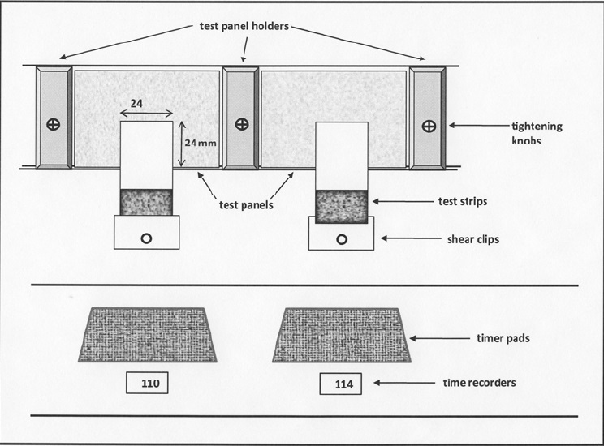

Figure 1. Test paneFiFigure 1. Test panel with sample and weight

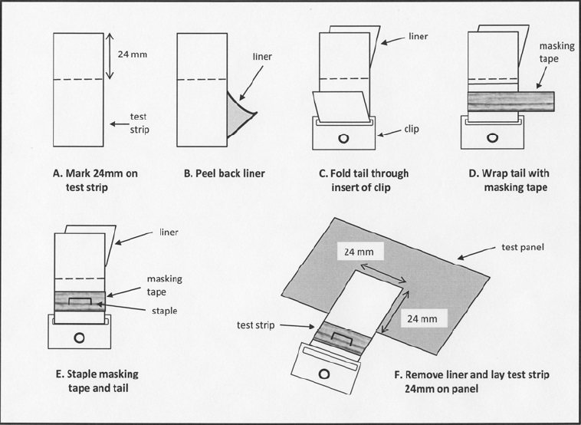

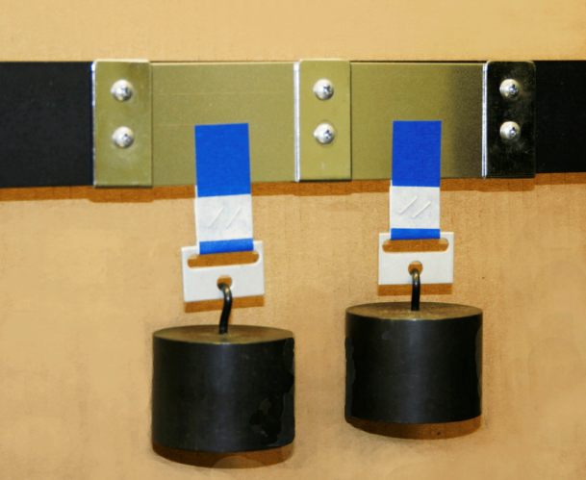

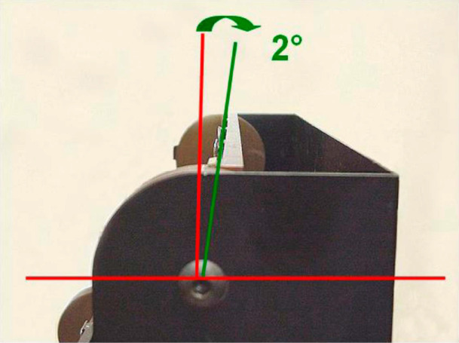

Figure 2.